Lab 5
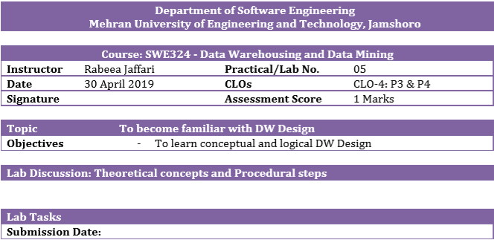
1. Draw M/ERDs for the following scenarios represented by ERDs and business rules to ease your task.

- Scenario 1: Advertising
Business Rules
1. Advertisements are placed by Agencies.
2. Advertisements are placed by Channels, such as TV or Print.
3. Advertisements can be part of a Marketing Campaign.
4. Invoices are produced and result in Payments.
5. Advertisements result in Responses.
6. Responses can be analysed by Demographics.
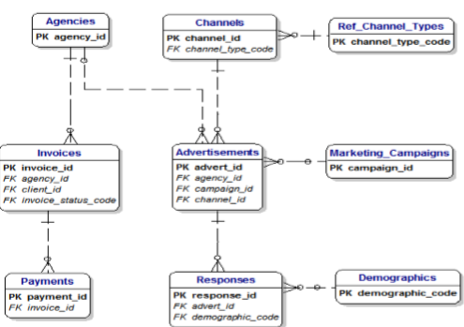
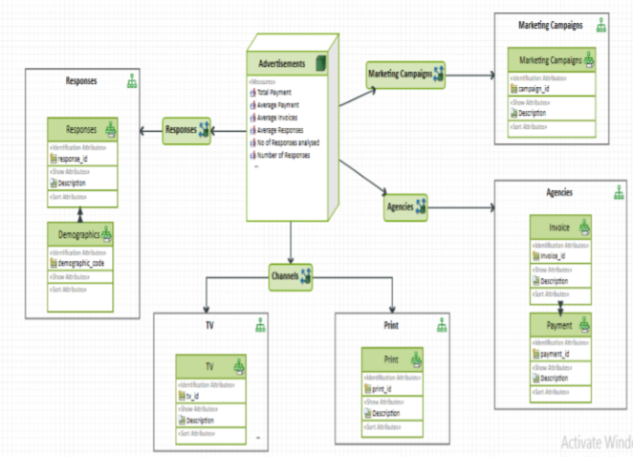

2. Scenario 3: Clown registry
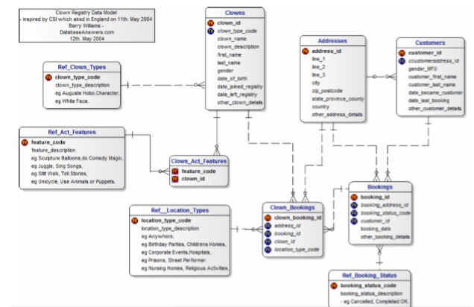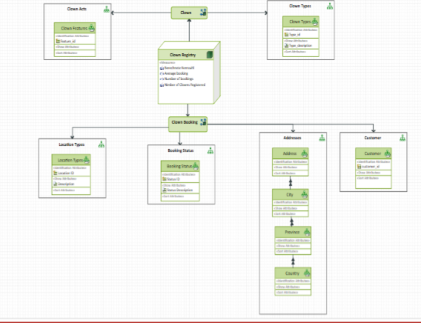
Business Rules
1. People registered as Clowns are stored in the Clowns Table.
2. A Clown can have Acts with specific Features.
3. Clowns accept Bookings to perform at specific Locations for specific Customers

